Bek Yongguang, Adrian
212A Compassvale Drive
#10-131
Singapore 541212
9816 3742 (HP)
DOB: 02 Aug 1981
adrianbyg@gmail.com

To whom it may concern,

Investments have always been a major part of my life. When I was a young boy, I would help my father report the price of Comfort share from Teletext. From then on, there was no looking back. I took the Diploma in Banking & Financial Services from Ngee Ann Polytechnic, graduated not only with a Diploma with Merit (awarded to top 5% of the cohort), I was the Gold Medallist (award to the top student of the cohort).

In Nanyang Technological University, while studying the Degree of Bachelor of Business (Applied Economics), my grades took a hit while I was President of the Hall of Residence 5. Hence, I only managed to graduate with a Second Class Honours (Lower Division). With that, the opportunity to work in the field of investments was close to nil as the competition is stiff and not only grades are looked upon, but the pedigree of the university as well.

As such, I worked as a fund accountant, starting in the traditional fund side, officially moving to the alternative investment (hedge fund) fund accounting in my second year at Citibank. I moved to my present firm, Sansar Capital Asia Pte. Ltd. in 2012. The yearning of being involved in investments did not disappear.

My financial advisor was the person looking after my portfolio of unit trusts. However I felt that the level of service provided by her did not commensurate with the fees that was paid which impacted the returns of the funds. Thus, I shifted my funds out from her and did it on my own through the Fundsupermart platform. I’m enclosing the screenshot of the performance of the funds since 2014. The annualised return is [1+(6,067.25/59,499.61)]^{1/3} – 1 = 0.0329.

I understand that I may not have the required hands-on the job experience of serving HNW or UHNW clients. However, I do believe that with a passion for investments and an eager to learn, obstacles can be overcomed.

I look forward in hearing from you.

Warmest regards,
Adrian Bek Yongguang

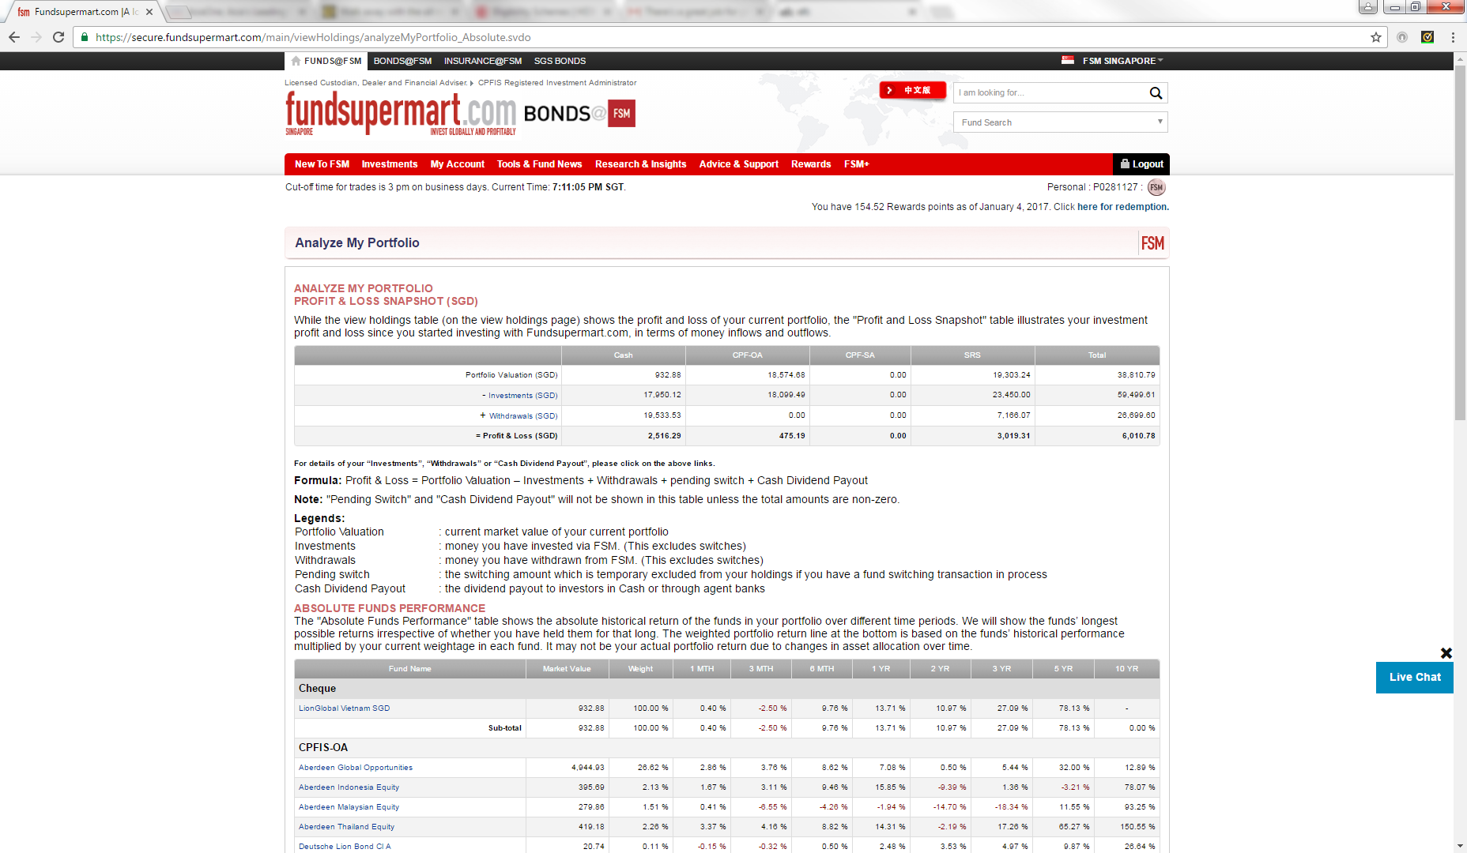

Bek Yongguang, Adrian
212A Compassvale Drive
#10-131
Singapore 541212
9816 3742 (HP)
DOB: 02 Aug 1981
adrianbyg@gmail.com
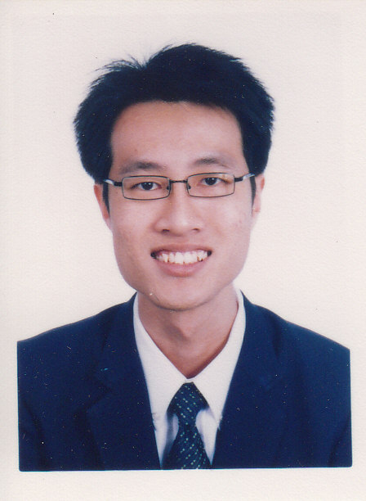

EMPLOYMENT HISTORY

Sansar Capital Asia Pte. Ltd. (Feb 2012 – Current)
Controller
Fund Accounting
- In charge of 5 feeder funds, 2 master funds and 1 standalone fund with a peak of 6 feeder funds, 3 master funds and 1 standalone fund.
- Prepare and review cash transfer instructions for inter-account transfers, swap unwinds and fee payments.
- Perform daily cash and stock reconciliations against Prime Broker/ISDA counterparties.
- Review monthly reconciliations, Gross Asset Valuation (GAV) and Net Asset Valuation (NAV ) reports and investors’ allocation schedule prepared by service provider.
- Review investors’ month end capital statements prepared by service provider.
- Prepare year - end audited US GAAP financial statements for 2 feeder funds, 1 master fund and 1 standalone fund. At the peak, it was 4 feeder funds, 2 master funds and 1 standalone fund.
- Assist in ah-hoc queries from investors.

Fund Operations
- Funds’ trade settlements.
  - Check trades against trader’s report and execution broker’s trade confirmations.
  - Input trades and send trade files to Prime Broker and Fund Administrator.
- In charge of pricing, corporate actions creations for portfolio.
- In charge of liaising with portfolio management system (PMS) vendor for troubleshooting.
- Provide daily and monthly profit/loss estimates to senior management.
- Assist in sending out monthly newsletter to investors.

Funds Migration
- Migrated all Sansar Capital Funds from one fund administrator to another.
  - Ensured all book costs, investors’ capital were correctly migrated over.

Regulatory Reporting
- USA reporting
  - Preparation of “Report of Foreign Bank and Financial Accounts” (FBAR).
  - Preparation of funds’ 1099 reporting.
  - Assist external tax accountants with the preparation of USA investors’ K-1s (Form 1065) and USA investors’ “Passive Foreign Investment Company” (PFIC) annual information statement.
  - Assisted in providing information for 13F, ADV and Form D filings.

- Cayman Islands
  - Preparation of “Fund Annual Return” (FAR) for Cayman Islands domiciled funds.

Exchange Reportings
- India Stock Exchanges
  - Prepare substantial shareholder’s reportings for National Stock Exchange and Bombay Stock Exchange.

Citibank N.A. (Feb 2008 – Feb 2012)
Fund Accounting Manager (Hedge Funds)
Management role
- Preparation of MIS reports (timeliness of NAV delivery, NAV production level, explanation on production level differences, revenue reporting).
- Unit representative for the Global Sustainability Initiative (GSI) and being the chair of GSI inside the Hedge Funds Unit to reduce carbon footprint that the unit produces.

Project Migration
- Part of the portfolio accounting system conversion team – being in charge of broker interfaces.
- Part of migration team to convert Mulitfonds to Geneva.

Fund Accounting Role
- New fund implementation
- Review Net Asset Valuation (NAV) of 5 Hedge Funds.
- Source of knowledge to team members and provided formalized training to team members apart from ad-hoc queries on equalization calculations, OTC derivatives valuation.
- Assist team members in work improvement processes with Excel macros/formulae for reconciliation.
- Reconcile investment managers’ securities transactions with Prime Broker/Custodian before input into portfolio accounting system.
- Prepare and review cash and securities reconciliations against actual bank balances and Prime Broker/Custodian positions.
- Review of security instruments’ corporate actions in portfolios.
- Review pricing of securities in portfolios.
- Review cash transfer instructions prepared by fund accountants.
- Liaising with clients and fund managers; interacting with trustees and counterparts within the bank; from Hong Kong, India, Malaysia and Thailand.
- Preparation of financial statements.

Citibank N.A. (Feb 2007 – Feb 2008)
Fund Accountant (Unit Trust Funds)
- Reconcile investment managers’ securities transactions with Prime Broker/Custodian before input into portfolio accounting system.
- Prepare and review cash and securities reconciliations against actual bank balances and Prime Broker/Custodian positions.
- Perform and review of security instruments’ corporate actions in portfolios.
- Prepare and review pricing of securities in portfolios.
- Perform Net Asset Valuation (NAV) for mutual funds, insurance linked funds and managed portfolios for Asia Pacific regional clients.
- Liaising with clients on queries and interact with trustees and counterparts within the bank to ensure service delivery.
- Preparation of financial statements.

Great Eastern Life (May 2005 – Jul 2005)
Internship (NTU Professional Attachment)
- Attached to Group Insurance Department.
- Job rotation at Marketing, Business Development, Underwriting, Customer Service, Claims, and Finance sections.

National Service Full-Time (Oct 2001 – Disrupted - Nov 2006)
Military Police
- Ensure security of the military installation.
- Data security of sensitive information.
- Discipline of military personnel.

Central Provident Fund (Jun 2001 – Sep 2001)
Temporary Clerk
- Processed CPF Pal Pin applications and confirm Pal Pin applications with CPF members.
- Confirm Pal Pin applications with CPF members.

EDUCATION

Nanyang Technological University (2003 – 2006)
Degree of Bachelor of Business (Applied Economics)
- Awarded Second Class Honours Lower Division
- Usage of econometrics modeling to examine the misalignment of the Chinese Yuan and possible effects on South East Asian nations for final year project.
- Econometrics modeling to examine relationships and forecast Gross Domestic Product of a few countries.

Ngee Ann Polytechnic (1998 – 2001)
Diploma in Banking & Financial Services
- Awarded DBS Bank Gold Medalist for top performance.
- Awarded Citibank Prize and DBS Bank Prize for top performance in Derivative Securities and Practice & Law of Banking in 2001.
- Awarded Silver Certificate of Achievement in CCA for outstanding performance in co-curricular activities.
- Awarded most outstanding performance 2000.
- Awarded prizes for best result in the modules of Business Ethics, Business Finance, Business Law, Financial Analysis, Principles of Credit Management and Productivity & Quality Studies.

CO-CURRICULAR ACTIVITIES

President, Junior Common Room Committee, Hall of Residence 5 (2004/2005)
- Led a team of 15 portfolios to organize monthly activities and ensure the welfare of 500 residents is taken care off.
- Liaised with University Administration for hostel policy changes.
- Attend monthly meetings with other Hall Presidents to set directions and pass approval for 3 major joint hall activities.

Financial Secretary, Junior Common Room Committee, Hall of Residence 5 (2003/2004)
- In charged of Hall of Residence 5’s financial accounts.
- Handled accounts in total exceeding $100,000.
- Liaised with 3 other internal hall committee’ financial controllers for
  - Their committees’ budget planning
  - Accounting their committee’s income and expenses
  - Reimbursement of their funds

Student Coordinator (SC), Business Studies Orientation Convention (1999/2000 and 2000/01)
- Orientated a group of 20 students around the polytechnic campus for 3 days with other student coordinators
  - Awarded Best SC in 2000/01.

CERTIFICATES

Nanyang Polytechnic (2010)
- Certificate in Fund Administration

ORGANISATION ACHIEVEMENT

Citibank NA
- Arc of Outstanding Performance, Team 2009 Q2 – Part of the team that set the necessary procedures and created the spreadsheets for the processing of a fund taken over from a rival fund administrator.
- RSC Star Program 2008 Q2 – Gold award winner for exemplary qualities of customer service, process improvement orientation, risk management and team play.

OTHER SKILLS
Computer Software Knowledge
- Microsoft Office including MS Access
- SPSS
- Multifonds (Portfolio Accounting software)
- Paxus (Portfolio Accounting software with equalization calculation)
- Geneva (Portfolio Accounting software)
- Tradar Insight (Portfolio Management Software)
- Bloomberg

Regression Modelling Technique
- Econometrics using Eviews5

HOBBIES

- Jogging to stay healthy.
- Window shopping to know more marketing concepts and target segments.
- Reading especially news to keep abreast with politics and financial markets.

REFEREES

To be provided upon request.

SALARY & AVAILABILITY

Current Salary: SGD 9,000 per month (SGD 108,000 per annum excluding bonus)
2015 Compensation: SGD 115,900 (Basic SGD 85,000 per annum, Bonus SGD 30,900)
Notice Period: 1 month

